

Course code**:** CSE360

Course title: Computer Interfacing

**Project Related Work**

Submitted by-

* Arjan Ghosh 20141045
* Mohibullah Hawlader 17101058
* Raad xxxxxxx

Submitted to

**Mr.Nazmus Sakeef**

**Lecturer**

**BRAC University**

**Introduction:** About a million people have died over the past 5 years in unmanned railway crossings all over the world. At least 1/3rd of the railway crossings are unmanned due to their remote placement and less traffic. On the other hand, Railway safety is the most crucial aspect of railways all over the world. The cheapest mode of transportation is railways, and therefore, accidents are likely to happen due to careless manual operations .The proposed system is enhanced to prevent accidents at the unmanned level crossings and to provide much needed safety. Automatic railway gate system can be employed in an unmanned level crossing where the chances of accidents are higher and reliable operation is required. Since, the operation is automatic, error due to manual operation is prevented. Automatic railway gate control is highly economical Arduino based arrangement, designed for use in almost all the unmanned level crossings in the country.

This assignment aims to provide an automatic railway gate control at the level crossing replacing the manual gate control. The railway gate is to be closed automatically when a train is passing by the railway crossing. The detection of arrival and departure of  train is done by using  two ultrasonic sensors. The opening and closing of the gate is to be done using stepper motors and this stepper motor is controlled by Arduino. Additionally the status of the gate will be given to the motorman well in advance. This insures more protection  from the accident. LED and alarm are used to indicate the closing of gate for the people who are trying to cross the gate.IR sensor are used for the proper closing of the gate. This system efficiently avoid the accidents at level crossing. Programming is done by Arduino C to operate hardware. Proposed methodology is more reliable and cost effective.

**Application Area**

Automatic Railway Gate Control System with High Speed Alerting System is an innovative circuit which automatically controls the operation of railway gates detecting the arrival and departure of trains at the gate .As it is automatic, it will reduce human effort and there will be a less chance of making mistake. Automatic railway gate control system reduce the time for which gate remains closed so less traffic will occur in a level crossing. Furthermore, This type of gates can be employed in an unmanned level crossing where the chances of accidents is higher and reliable operation is required. Automatic operation prevents errors due to manual operation .Lastly, no human resource is required. This makes its running cost very low compared to manned gates.

**Technology and Tools:**

* Arduino mega as micro-controller
* Two ultrasonic sensors
* Two IR sensors
* One buzzer
* One LED
* One GSM
* Two stepper motors
* TwoULN 2003A IC
* One breadboard
* Jumper wires

**Language:** We will useC programming Language for coding  or implementing the command.

**Working mechanism**

The hardware used in the automatic railway gate controller is discussed below. The main component for the system and their working is explained shortly as follows:

**Arduino Mega 2560**

The Arduino Mega 2560 is a microcontroller board based on the [ATmega2560](http://ww1.microchip.com/downloads/en/DeviceDoc/Atmel-2549-8-bit-AVR-Microcontroller-ATmega640-1280-1281-2560-2561_datasheet.pdf). It has 54 digital input/output pins (of which 15 can be used as PWM outputs), 16 analog inputs, 4 UARTs (hardware serial ports), a 16 MHz crystal oscillator, a USB connection, a power jack, an ICSP header, and a reset button. It contains everything needed to support the microcontroller; simply connect it to a computer with a USB cable or power it with a AC-to-DC adapter or battery to get started.

In our assignment arduino mega 2560 is used as a controller to operate all the digital and analog components. It is interfaced with sensors, stepper motor and GSM to get the proper results.

**IR Sensor**

An I[nfrared sensor](https://www.elprocus.com/ir-remote-control-basics-operation-application/) is an electronic device, that emits in order to sense some aspects of the surroundings. An IR sensor can measure the heat of an object as well as detects the motion. These types of sensors measure only infrared radiation, rather than emitting it that is called a [passive IR sensor](https://www.elprocus.com/passive-infrared-pir-sensor-with-applications/). Usually, in the infrared spectrum, all the objects radiate some form of thermal radiation. These types of radiations are invisible to our eyes, that can be detected by an infrared sensor. The emitter is simply an IR LED ([Light Emitting Diode](https://www.elprocus.com/explain-different-types-leds-working-applications-engineering-students/)) and the detector is simply an IR photodiode that is sensitive to IR light of the same wavelength as that emitted by the IR LED. When IR light falls on the photodiode, the resistances and the output voltages will change in proportion to the magnitude of the IR light received.

IR transmitter and Receiver IR Transmitter and Receiver are used to check if the gate is properly closed or not. If the gate is not closed properly IR will give signal to the Arduino.

**Buzzer**

A buzzer or beeper is an audio signalling device, which may be mechanical, electromechanical, or piezoelectric (piezo for short). Typical uses of buzzers an beepers include alarm devices, timers, and confirmation of user input such as a mouse click or keystroke.

Buzzer is used to warn the people at railway crossing that train is coming. Buzzer is  also used at critical situations if gate is not closed to warn people.

**Ultrasonic Sensor**

As the name indicates, ultrasonic sensors measure distance by using ultrasonic waves. The sensor head emits an ultrasonic wave and receives the wave reflected back from the target. Ultrasonic Sensors measure the distance to the target by measuring the time between the emission and reception.

All Ultrasonic sensors are used to detect arrival and departure of the gate near and away to the railway crossing respectively. They are placed at two sides of railway crossing. Ultrasonic sensor gives the accurate distance in terms of centimeter so that we can detect the trains.

**Stepper Motor**

A stepper motor is a device which requires an input electrical potential difference to operate and converts it into discretely incrementing rotational movement of its central rotor/shaft mechanism. The rotation of the spindle is executed through discrete steps which are in response to the applied electrical pulses.

Stepper motor is used to rotate gate clockwise as well as anticlockwise for opening and closing of gate. Stepper motor can be programmed in terms of number of steps and angle.

**ULN 2003A**

The ULN2003A is an array of seven NPN Darlington transistors capable of 500 mA, 50 V output. It features common-cathode flyback diodes for switching inductive loads.

ULN 2003A is used to interface stepper motor and arduino. ULN2003A is used to amplify the control signal from the Arduino. It can Drive voltage can up to 15v.

**LED**

Light Emitting Diodes are basically tiny light bulbs that fit easily into an electrical circuit.LEDs are illuminated by the movement of electrons in a semiconductor material.

LED is used to display the status of the gate to the people who are crossing the railway gate crossing.

**GSM**

GSM stands for Global System for Mobile Communication. It is a digital cellular technology used for transmitting mobile voice and data services.

GSM is used to send the status of the gate to the motorman via SMS on  mobile phone. So that motorman can analyze the situation and take further action.

**Connection with Arduino Mega 2560**

The connection mechanism  of the arduino with the  I/O devices  and the sensors are as follows : First ,we know that UltraSonic sensor is consist of 4 pins : GND,VCC, TRG,ECHO .We will connect  the GND of the first  UltraSonic sensor with arduino’s GND (  common GND will be established in Breadboard ).Then,we will connect the VCC of the UltraSonic sensor with arduino’s VCC (  common VCC will be established in Breadboard ).Later , the ECHO  pin of the UltraSonic sensor will be connected with the Digital pin no : 02 and the TRG pin will be connected to Digital pin no: 03.To connect the first  stepper motor we need motor driver .Here we are usingULN 2003AIC .We are using  arduino’s digital pin no :4,5,6,7 to connect the 4 input pins of the IC, which are 1,2,3,4  and the GND will be connected with the arduino’s GND.Now,  BLU,PIK,YHL,ORG coils of the stepper motor will be connected with the output pins which are 16,15,14,13 and the RED pin will be connected with the GND of arduino and the COM of the IC.To connect the second  stepper motor we need another  ULN 2003A.We are using  arduino’s digital pin no :8,9,10,11 to connect the 4 input pins of the IC, which are 1,2,3,4  and the GND will be connected with the arduino’s GND.Now,  BLU,PIK,YHL,ORG coils of the stepper motor will be connected with the output pins which are 16,15,14,13 and the RED pin will be connected with the GND of arduino and the COM of the IC. Next, we will use digital pin no:12

Of the arduino to connect the anode of the buzzer and the cathode of the buzzer will be connected to the ground of the arduino . Furthermore, we will use digital pin no:13

Of the arduino to connect the anode of the LED  and the cathode of the LED will be connected to the ground of the arduino . We will connect  the GND of the second   UltraSonic sensor with arduino’s GND (  common GND will be established in Breadboard ).Then,we will connect the VCC of the UltraSonic sensor with arduino’s VCC (  common VCC will be established in Breadboard ).Later , the ECHO  pin of the UltraSonic sensor will be connected with the Digital pin no : 14 and the TRG pin will be connected to Digital pin no: 15.We will connect  the GND of the first  IR  sensor with arduino’s GND .Then,we will connect the VCC of the IR sensor with arduino’s VCC and the output pin of the IR sensor will be connected with the digital pin no: 16.Similarly ,We will connect  the GND of the second   IR  sensor with arduino’s GND .Then,we will connect the VCC of the IRsensor with arduino’s VCC and the output pin of the IR sensor will be connected with the digital pin no: 17. Finally, we will connect the GND pin of the GSM modem to the common GND of arduino and the vcc  pin will be connected to the common vcc of arduino. The TXD pin of the modem will be connected to the digital pin no :18 and the RXD pin of the modem will be connected to the digital pin no :19 .

**Data Flow :**

Arduino mega 2560 acts as a controller of this system. It is used to perform following function:  It is interfaced with ultrasonic sensor to detect arrival and departure of the train.  With the help of two stepper motor it opens and closes the gate.  It also sends the status of the signal to the motorman via GSM modem.  Buzzer is used to warn the people that gate is closing.  It displays the status of the railway gate using LED.  It is interfaced with IR to ensure the gate is properly closed.  The programming of this system is done by Arduino C language.

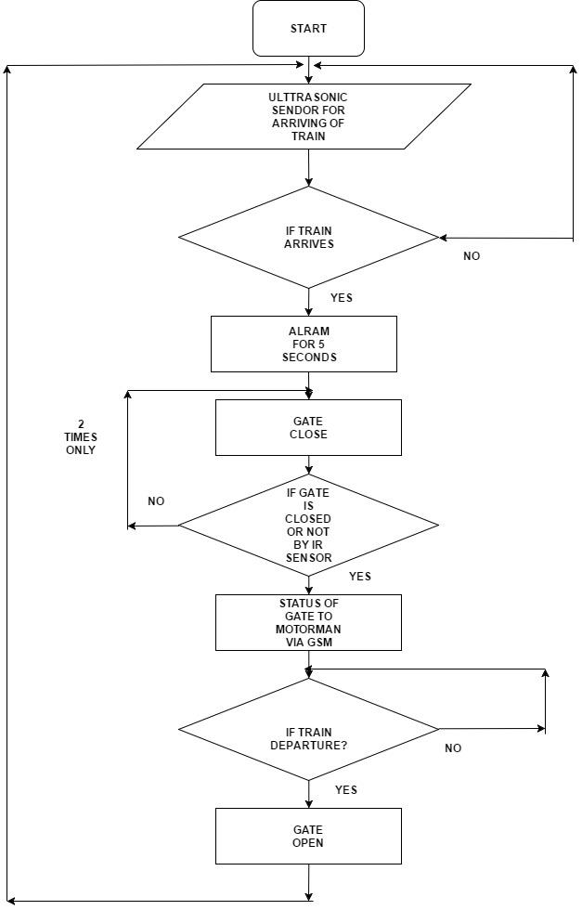

The method used in the flow chart   are described in steps below:

STEP 1:  Check the ultrasonic sensor 1 for detection of   arrival of train.

STEP 2:  If train arrives go to step no. 3 else go to step no.1.

STEP 3:  Ring alarm for 30 second.

STEP 4:  Close the gate with the help of stepper motor.

STEP 5:  Check if the gate is closed or not with the help of IR sensor if gate is closed go to step no 6 else go to step no 4.Go to step no 4 only two times.

STEP 6:  Send the status of the gate to the motorman via GSM modem.

STEP 7:Check ultrasonic sensor 2 for the departure of train. If train crosses the ultrasonic sensor go to step 8 else check again.

STEP 8: Wait for 30 sec and open the gate.

Case1:                                                                                                                                                                                                                                  Normal case

**Case1**: Normal case This is the general case for the train 1. IF the train is detected Arduino will try to close the gate. The proper closing of the gate will be confirmed by the IR Sensor pair and the message “Gate is closed” will be given to the motorman.

**Case2**: Emergency case Second case is if the gate is not closed properly is detected by IR Sensors then the system will wait for the manual operation and this is an emergency case where proper actions has to be taken. The message of the open gate will be given to the motorman.

**Case3:** Problem handling case In this case the gate is not closed properly and after some time the problem has been handled may be by manual control or may be by system itself then the gate will be closed. The message that “Gate is closed” will be given to the motorman.

**Case4**: Case considering two tracks This similar case as case 1 only the difference is train is coming from opposite direction.

**Cost Analysis**

|  |  |  |
| --- | --- | --- |
| **Component Name** | **Quantity** | **Price**  **(BDT)** |
| **Arduino Mega 2560** | **1** | **750** |
| **IR Sensors** | **2** | **140** |
| **Ultrasonic Sensors** | **2** | **6000** |
| **Stepper Motor** | **2** | **2500** |
| **Buzzer** | **1** | **45** |
| **ULN 2003A** | **2** | **40** |
| **GSM** | **1** | **400** |
| **wire** |  | **20** |
| **Breadboard** | **1** | **100** |
| **LED** | **1** | **2** |

**Conclusion :**The proposed system is enhanced to prevent accidents at the unmanned level crossings and to provide much needed safety. Automatic railway gate system can be employed in an unmanned level crossing where the chances of accidents are higher and reliable operation is required. Since, the operation is automatic, error due to manual operation is prevented. Automatic railway gate control is highly economical Arduino based arrangement, designed for use in almost all the unmanned level crossings in the country.Though,our system is not the least cost effective because of using expensive ultrasonic sensors but,it ensures more and higher safety than any existing level crossing system as it has very high efficient backup system to control the level crossing in case of whole system failure due to technical damages.